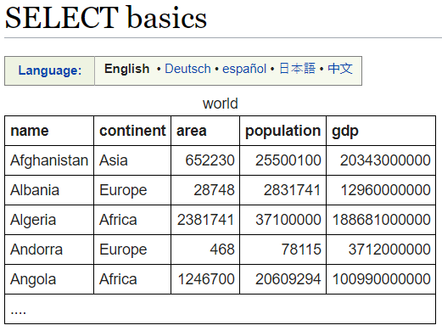



**SELECT population FROM world WHERE name = 'Germany'**

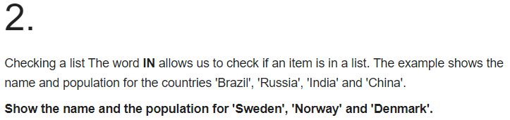

**SELECT name, population FROM world WHERE name IN ('Sweden', 'Norway', 'Denmark');**

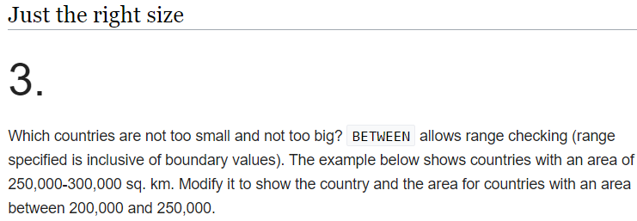

**SELECT name, area FROM world WHERE area BETWEEN 200000 AND 250000**